Cryptography and Network Security Lab

Assignment 10  
Implementation and Understanding of RSA Algorithm

2019BTECS00058  
Devang K

Batch: B2

Title: Implementation and Understanding of RSA Algorithm

Aim: To Study, Implement and Demonstrate the RSA Algorithm

Theory:

RSA (Rivest–Shamir–Adleman) is a public-key cryptosystem that is widely used for secure data transmission. It is also one of the oldest. The acronym "RSA" comes from the surnames of Ron Rivest, Adi Shamir and Leonard Adleman, who publicly described the algorithm in 1977. An equivalent system was developed secretly in 1973 at GCHQ (the British signals intelligence agency) by the English mathematician Clifford Cocks. That system was declassified in 1997.

In a public-key cryptosystem, the encryption key is public and distinct from the decryption key, which is kept secret (private). An RSA user creates and publishes a public key based on two large prime numbers, along with an auxiliary value. The prime numbers are kept secret. Messages can be encrypted by anyone, via the public key, but can only be decoded by someone who knows the prime numbers.

The security of RSA relies on the practical difficulty of factoring the product of two large prime numbers, the "factoring problem". Breaking RSA encryption is known as the RSA problem. Whether it is as difficult as the factoring problem is an open question. There are no published methods to defeat the system if a large enough key is used.

RSA is a relatively slow algorithm. Because of this, it is not commonly used to directly encrypt user data. More often, RSA is used to transmit shared keys for symmetric-key cryptography, which are then used for bulk encryption–decryption.

Operation:

The RSA algorithm involves four steps: key generation, key distribution, encryption, and decryption.

A basic principle behind RSA is the observation that it is practical to find three very large positive integers e, d, and n, such that with modular exponentiation for all integers m (with 0 ≤ m < n):

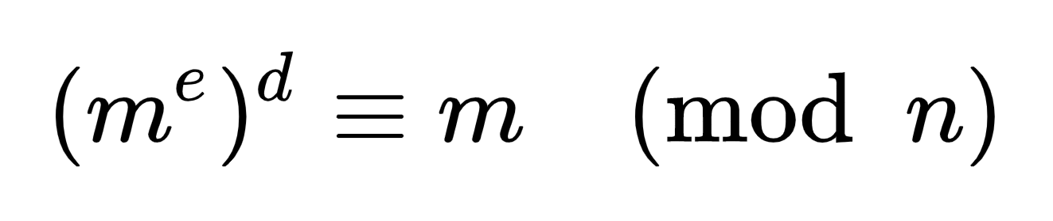

and that knowing e and n, or even m, it can be extremely difficult to find d. The triple bar (≡) here denotes modular congruence (which is to say that when you divide (me)d by n and m by n, they both have the same remainder).

In addition, for some operations it is convenient that the order of the two exponentiations can be changed and that this relation also implies:

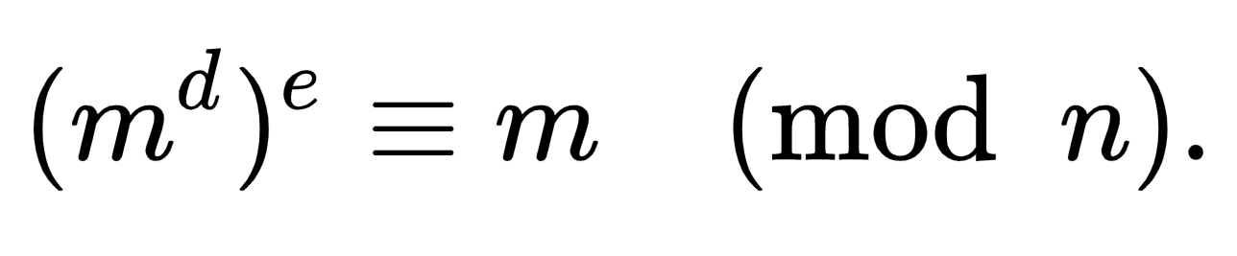

RSA involves a public key and a private key. The public key can be known by everyone and is used for encrypting messages. The intention is that messages encrypted with the public key can only be decrypted in a reasonable amount of time by using the private key. The public key is represented by the integers n and e, and the private key by the integer d (although n is also used during the decryption process, so it might be considered to be a part of the private key too). m represents the message (previously prepared with a certain technique explained below).

This is the crux of the RSA algorithm.

Essentially, we first convert the string to numbers, then encrypt the large number. Decryption is similar – we get our original number which can be converted to the plaintext.

Code:

*from* os *import* system, name

*import* msvcrt

*import* rsa

*import* sys

*def* ConvertToInt(message):

    theNumber = "1"

*for* m *in* message:

        theASCII = str(ord(m))

*if* len(theASCII) == 1:

            theASCII = "00"+theASCII

*elif* len(theASCII) == 2:

            theASCII = "0"+theASCII

        theNumber += theASCII

*return* int(theNumber)

*def* clear():

*if* name == 'nt':

        _ = system('cls')

*else*:

        _ = system('clear')

*def* Generate_Keys():

    clear()

    print("\n\n*************************Key Generation*************************\n")

    (pubkey, privkey) = rsa.newkeys(512)

    print("Your Public Keys 'e' and 'n' respectively are:")

    print(pubkey.e)

    print()

    print(pubkey.n)

    print("\nYour Private Keys 'd' and 'n' respectively are:")

    print(privkey.d)

    print()

    print(privkey.n)

    print("Warning: Don't share your Private Keys with Anyone!")

    print("Press Any Key to Go Back")

    msvcrt.getch()

    home()

*def* Encrypt_Dat():

    clear()

    print("\n\n*************************Encryption*************************\n")

    print("Enter the Message to Encrypt:")

    contents = []

*while* True:

*try*:

            line = input()

            line.lstrip()

            line.rstrip()

*if* len(line) == 0:

*break*

*except* EOFError:

*break*

        contents.append(line)

    print("Enter 'n' of Receiver:")

    n = input()

    print("Enter 'e' of Receiver:")

    e = input()

    encry = []

    print("\nEncoded Message is:")

*for* line *in* contents:

        mess = ConvertToInt(line)

        mess = pow(mess, int(e), int(n))

        encry.append(mess)

*for* line *in* encry:

        print(line)

    print("\nPress Any Key to Continue.")

    msvcrt.getch()

    home()

*def* PowMod(a, n, mod):

*if* n == 0:

*return* 1 % mod

*elif* n == 1:

*return* a % mod

*else*:

        b = PowMod(a, n // 2, mod)

        b = b * b % mod

*if* n % 2 == 0:

*return* b

*else*:

*return* b * a % mod

*def* ExtendedEuclid(a, b):

*if* b == 0:

*return* (1, 0)

    (x, y) = ExtendedEuclid(b, a % b)

    k = a // b

*return* (y, x - k * y)

*def* InvertModulo(a, n):

    (b, x) = ExtendedEuclid(a, n)

*if* b < 0:

        b = (b % n + n) % n

*return* b

*def* Decrypt(ciphertext, d, n):

*return* ConvertToStr(PowMod(ciphertext, d, n))

*def* ConvertToStr(numbers):

    numbers = str(numbers)

    numbers = numbers[1:]

    theMessageList = [numbers[i:i+3] *for* i *in* range(0, len(numbers), 3)]

    theMessage = ""

*for* tml *in* theMessageList:

        theMessage += chr(int(tml))

*return* theMessage

*def* Decrypt_Dat():

    clear()

    print("\n\n*************************Decryption*************************\n")

    print("Enter Message to Decrypt:")

    obey = []

*while* True:

*try*:

            line = input()

            line.lstrip()

            line.rstrip()

*if* len(line) == 0:

*break*

*except* EOFError:

*break*

        obey.append(int(line))

*# print("\nEnter Private Key 'p':")*

*# p = int(input())*

*# print("\nEnter Private Key 'q':")*

*# q = int(input())*

    print("\nEnter Private Key 'd':")

    d = int(input())

    print("\nEnter Your Public Key 'n':")

    n = int(input())

    print("\n\nMessage as Decrypted:")

*for* line *in* obey:

        print(Decrypt(line, d, n))

    print("\nPress Any Key to Continue.")

    msvcrt.getch()

    home()

*def* home():

    clear()

    print("\n\n*************************DeSipher*************************\n")

    print("Choose your Action:")

    print("\t1. Encrypt Data.")

    print("\t2. Decrypt Data.")

    print("\t3. Generate Public and Private Keys.")

    print("\t4. Exit.")

    print("\nYour Choice: ", end='')

    inp = input()

*if* inp == '1':

        Encrypt_Dat()

*elif* inp == '2':

        Decrypt_Dat()

*elif* inp == '3':

        Generate_Keys()

*elif* inp == '4':

        sys.exit()

*else*:

        print("Invalid Choice.")

        print("Try Again.")

        print("Press Any Key To Continue.")

        msvcrt.getch()

        home()

home()

We now illustrate with examples:

We need to first generate 2 public and private keys:

For our 2 users – Alice and Bob.

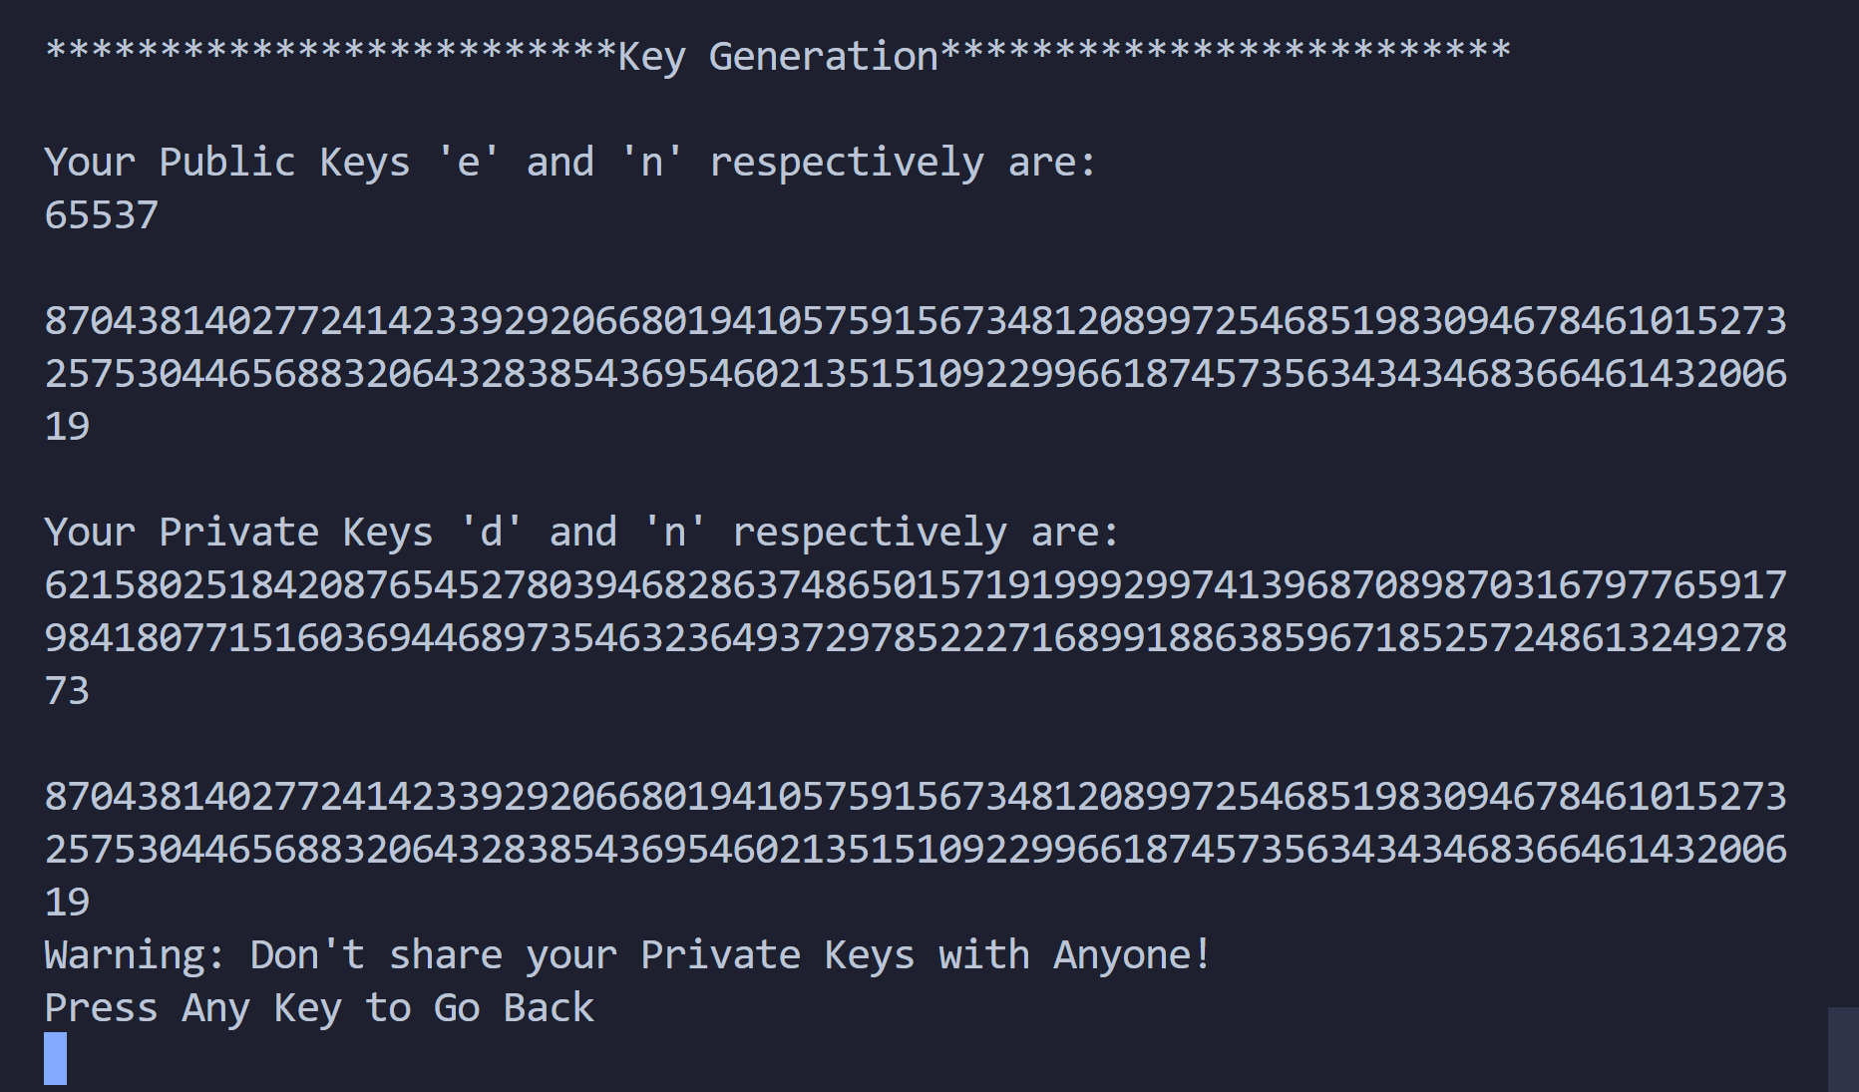

Your Public Keys 'e' and 'n' respectively are:

65537

8704381402772414233929206680194105759156734812089972546851983094678461015273257530446568832064328385436954602135151092299661874573563434346836646143200619

Your Private Keys 'd' and 'n' respectively are:

6215802518420876545278039468286374865015719199929974139687089870316797765917984180771516036944689735463236493729785222716899188638596718525724861324927873

8704381402772414233929206680194105759156734812089972546851983094678461015273257530446568832064328385436954602135151092299661874573563434346836646143200619

Then for Bob:

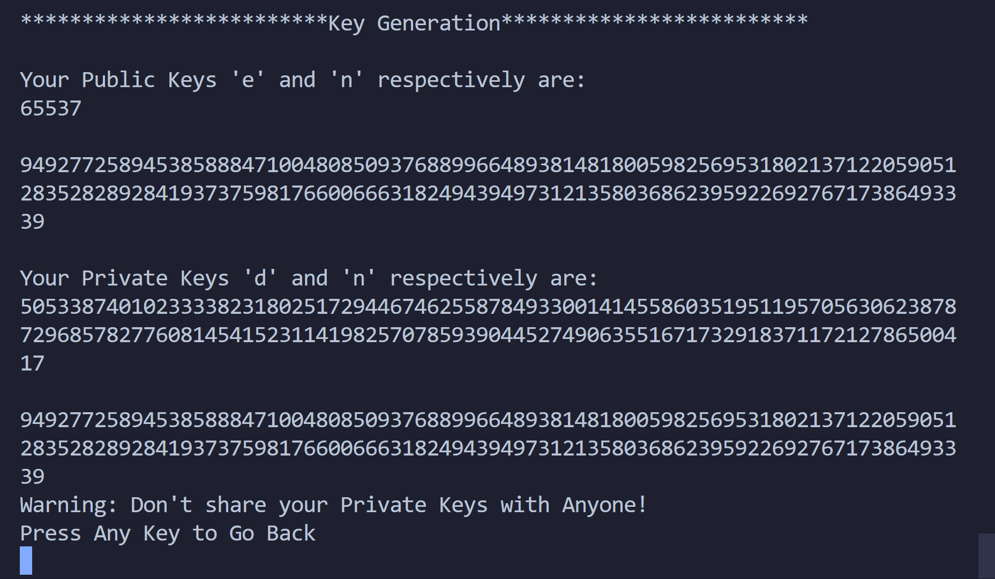

Your Public Keys 'e' and 'n' respectively are:

65537

9492772589453858884710048085093768899664893814818005982569531802137122059051283528289284193737598176600666318249439497312135803686239592269276717386493339

Your Private Keys 'd' and 'n' respectively are:

5053387401023333823180251729446746255878493300141455860351951195705630623878729685782776081454152311419825707859390445274906355167173291837117212786500417

9492772589453858884710048085093768899664893814818005982569531802137122059051283528289284193737598176600666318249439497312135803686239592269276717386493339

Now, say Alice wishes to share a message to Bob. She would send the message using Bob’s public key.

She wishes to send – ‘Osama is spotted in Abbottabad. Reach ASAP’.

This would work as follows:

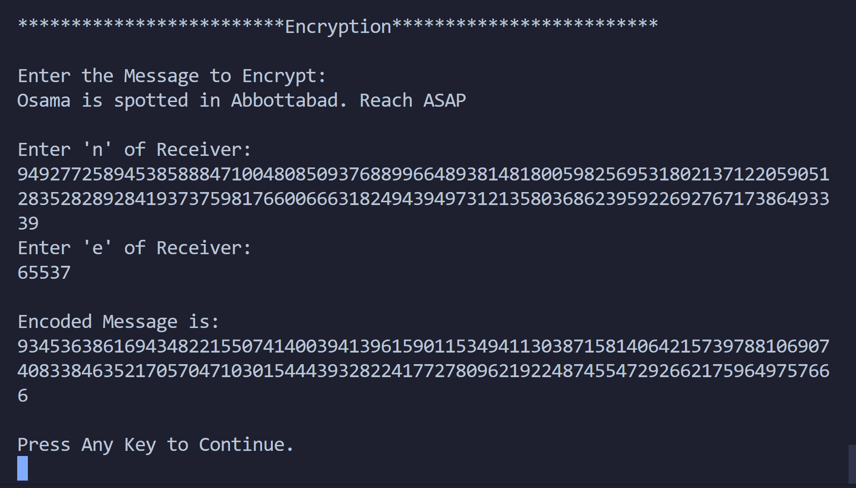

Encoded Message is:

934536386169434822155074140039413961590115349411303871581406421573978810690740833846352170570471030154443932822417727809621922487455472926621759649757666

When Bob would receive this message, he would decrypt using his private key.

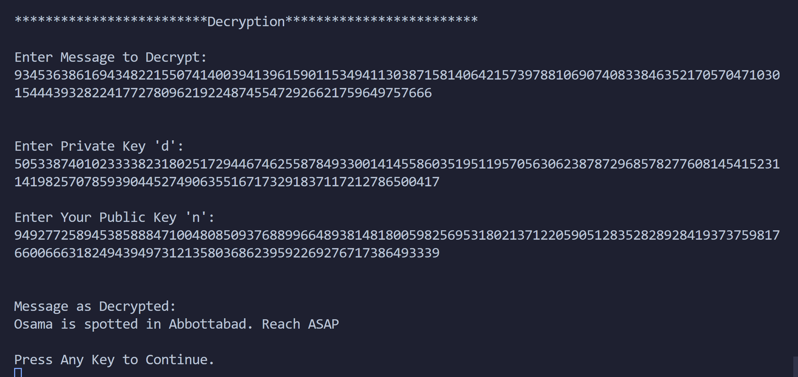

We receive our plaintext back.

Now say Bob wishes to message ‘Okay’ to Alice.

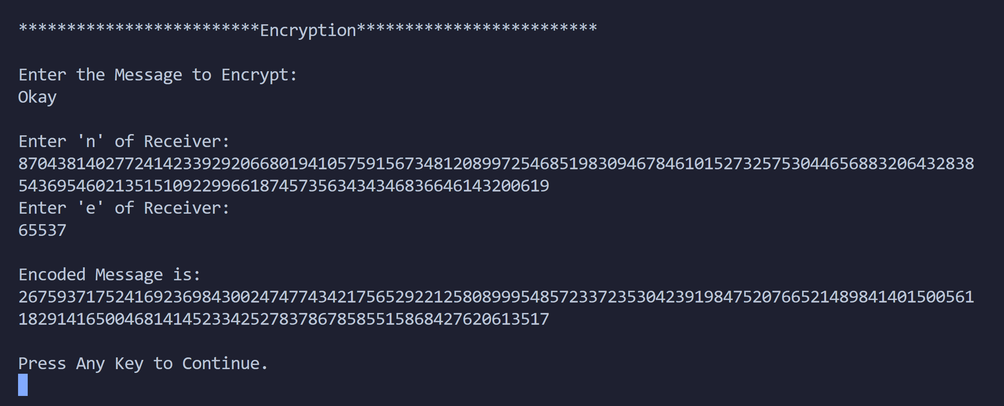

Encoded Message is:

2675937175241692369843002474774342175652922125808999548572337235304239198475207665214898414015005611829141650046814145233425278378678585515868427620613517

Then Alice would decrypt using her private key:

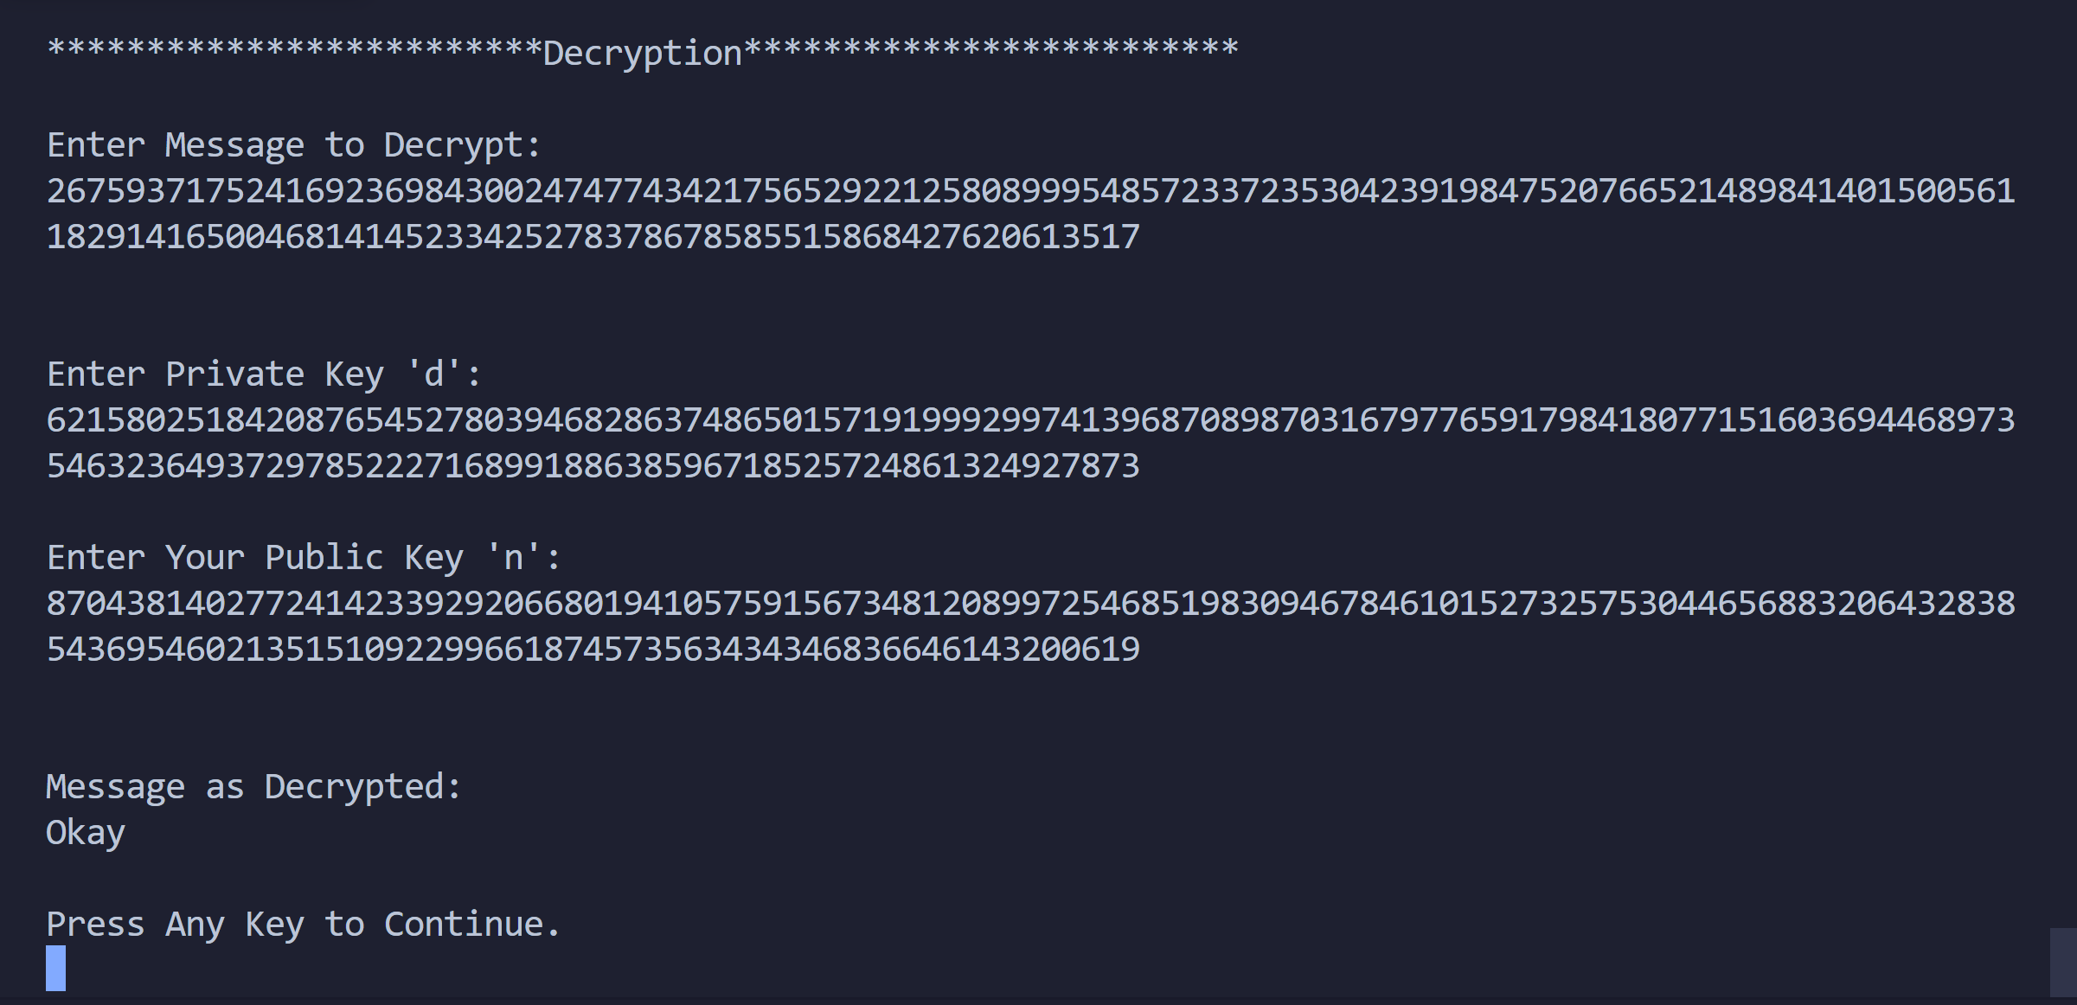

Thus, she received the message from Bob.

Thu, we illustrated working of RSA in the code.

Conclusion:

Thus, the RSA algorithm was studied and demonstrated with the code.